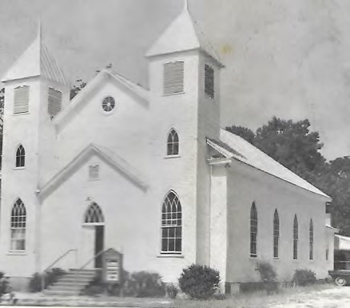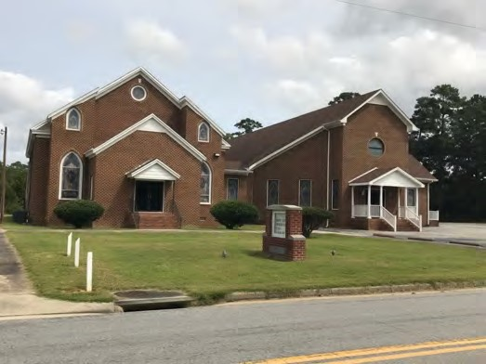

150
th Anniversary

“Rooted in Faith, Honoring Our Legacy”

1869

-
2019

Lebanon Baptist Church

Surry County, Virginia

Reverend Dr. Douglas F. Adams, Jr., Pastor

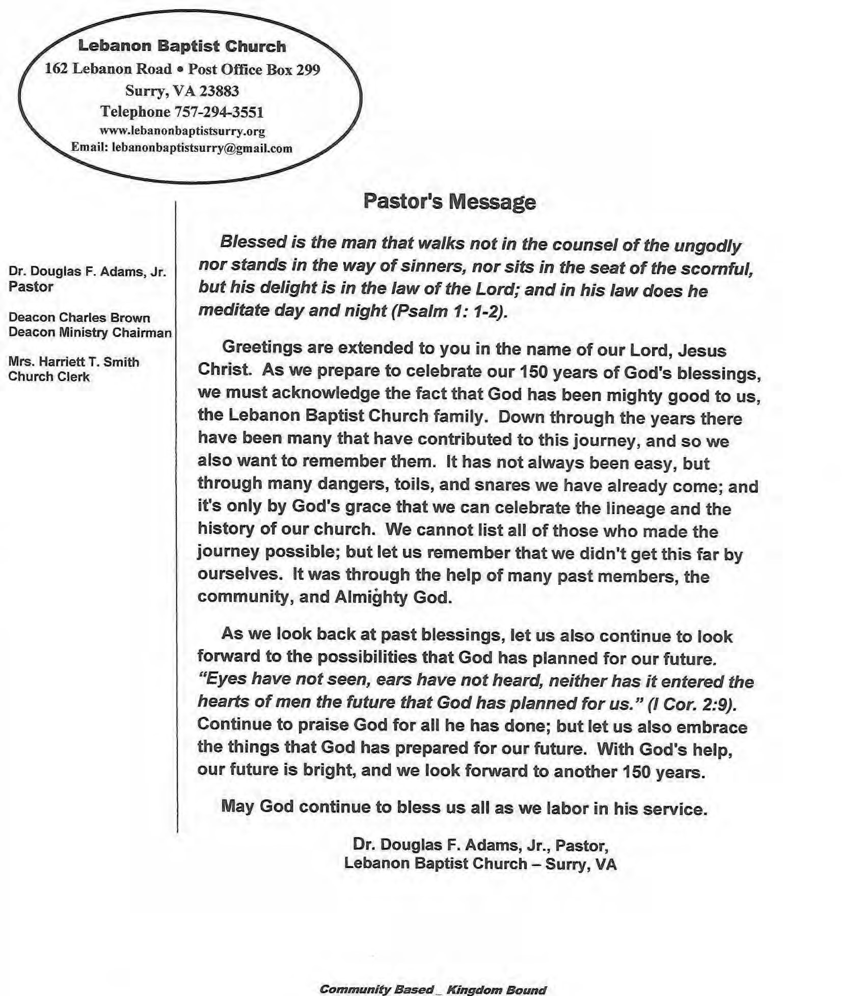

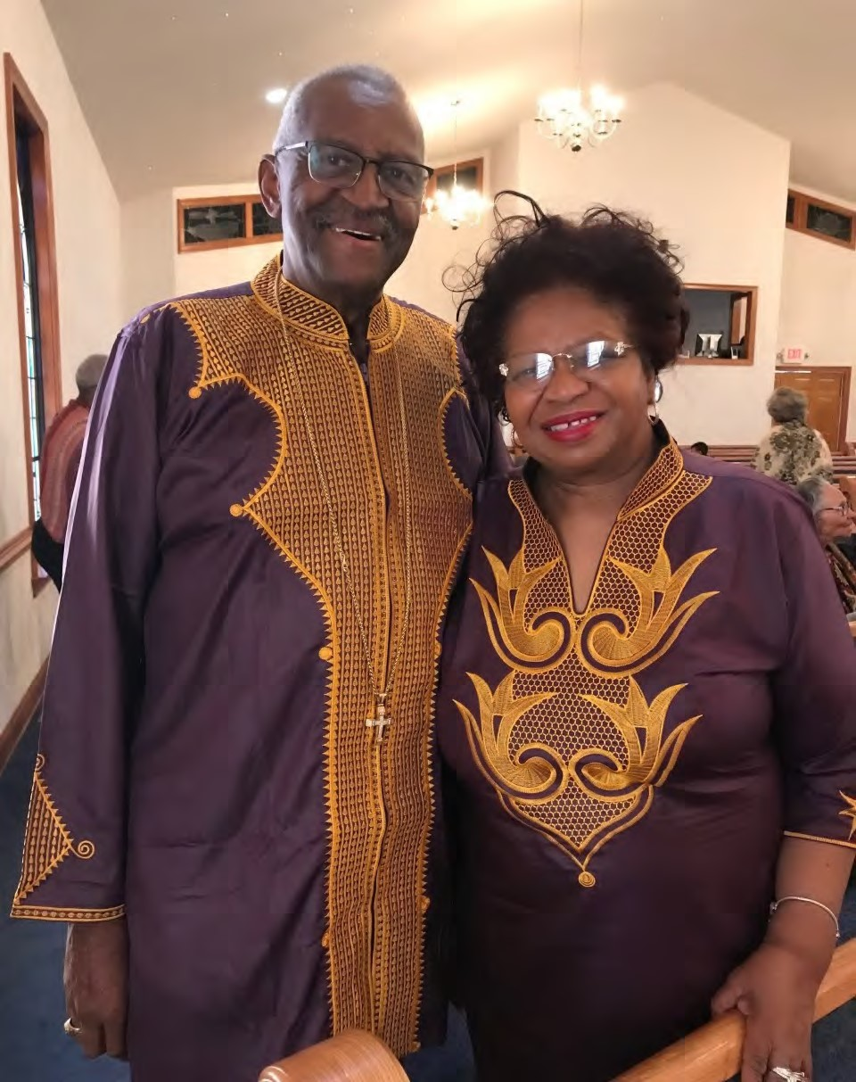

Rev. Dr. Douglas F. Adams and
Mrs. Vergena Adams

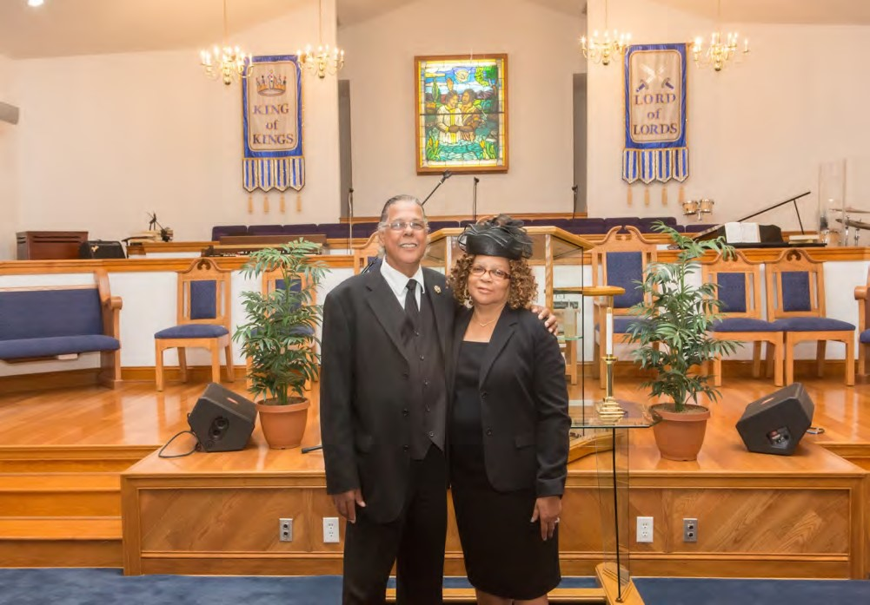

Associate Minister Rev. Dennis E. Harrison and
Deaconess Barbara J. Harrison

Community Greetings

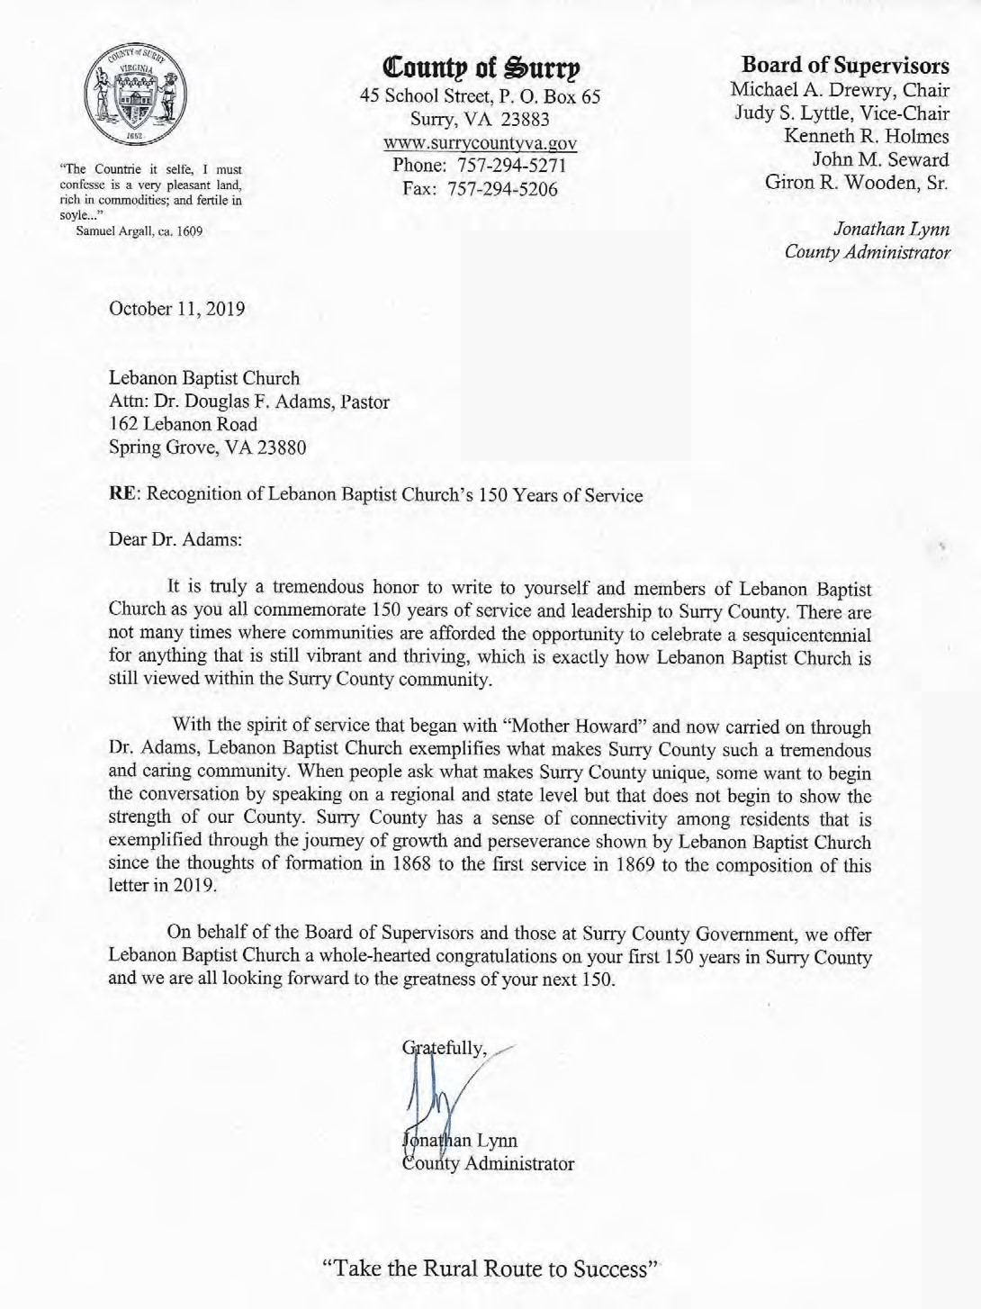

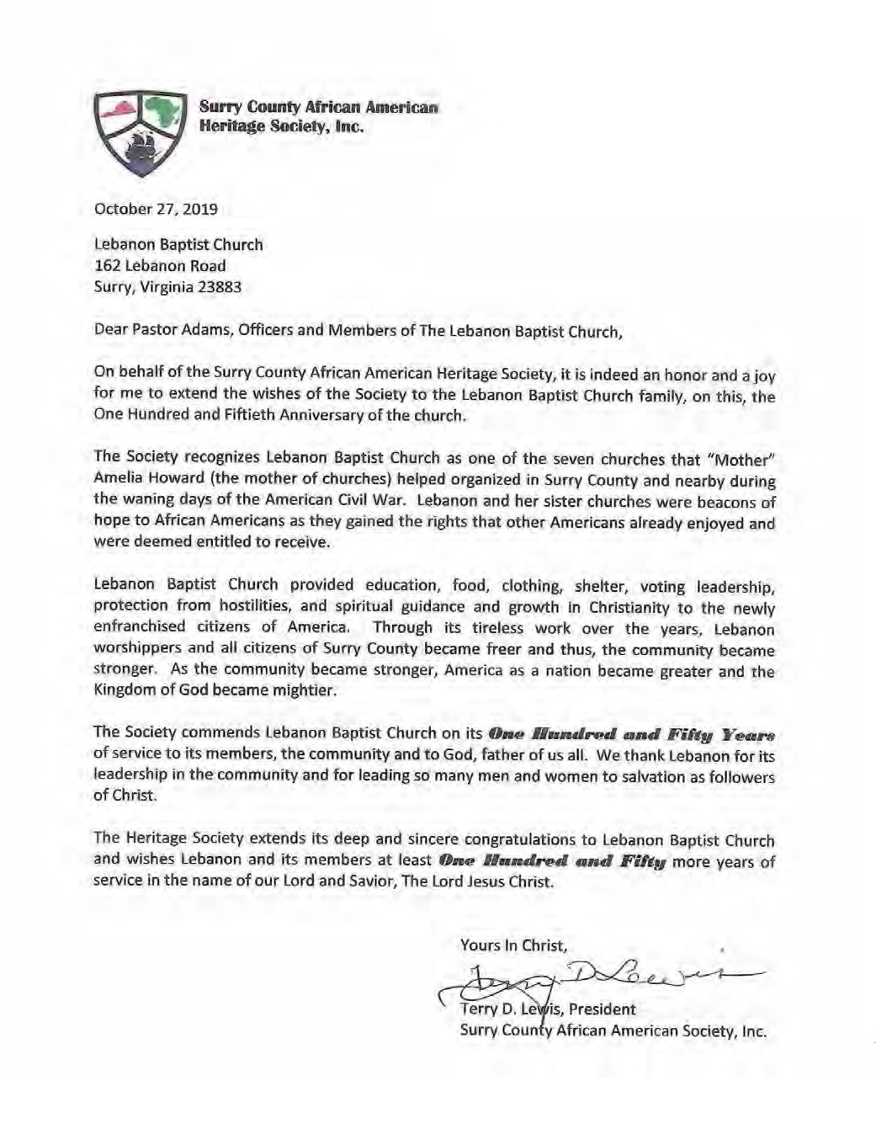

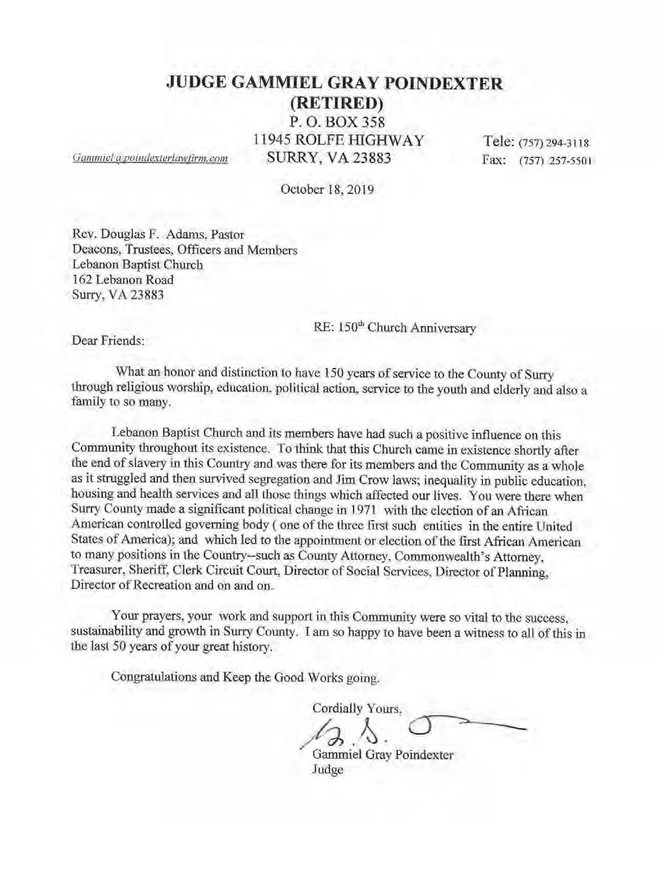

Anniversary Services

Lebanon Baptist Church 150th Anniversary

1869
-
2019

Anniversary Banquet

Saturday, November 2, 2019

4:00
p.m.

Musical Interlude

Rick Elliott

Presentation of Mistress of Ceremony

Deaconess Harriett Smith

Mistress of Ceremony

Dr. Kelly Doswell, EdD

Opening Selection

“We’ve Come This Far by Faith”

Prayer

Reverend Dennis Harrison

Welcome and Purpose

Sister Phyllis Thomas

Brother Clarence White

Vocal Duet

Sister Brenda Tynes and Deacon Johnnie Johns

(
Accompanied by Reverend Ivan Pretlow
)

Blessing of Food

Deacon Thaddeus Lane, Jr.

~Dinner is Served~

Vocal Duet

Sister LaSonya White and Deacon Johnnie Johns

(
Accompanied by Reverend Ivan Pretlow
)

Introduction of Speaker

Speaker

Deaconess Elva Whitten

Popular Lawn Baptist Church

Closing Remarks

Reverend Dr. Douglas F. Adams, Jr.

Lebanon Baptist Church
150th Church Anniversary
1869 - 2019 Sunday, November 3, 2019 2:00 p.m.

“Rooted in Faith, Honoring Our Legacy”
 |  | Worship Leader | Deacon Thaddeus C. Lane, Jr.
 |  | Opening Selection | Guest Choir
 |  | Scripture | Sister Clara Bailey
 |  | Prayer | Deacon Carlos Turner
 |  | Musical Selection | Guest Choir
 |  | Welcome | Deaconess Janice Brown
 |  | Highlights of Church History | Sister Deborah H. Dawson
 |  | Musical Selection | Guest Choir
 |  | Offering | Deacons
 |  | Introduction of Guest Speaker | Pastor Douglas F. Adams
 |  | Musical Selection | Guest Choir
 |  | Anniversary Message | Rev. Dr. Bobby Lee Taylor, Pastor  Sandy Mount Baptist Church  Smithfield, VA
 |  | Invitation to Christian Discipleship | Minister
 |  | Remarks | Pastor Adams  Deaconess Harriett Smith
 |  | Benediction | Minister

History of Lebanon Baptist Church

Rev. W. Herbert George’s book, The History of Negro Churches in Surry County, Virginia, published around 1983 states that:

“The Lebanon Baptist Church, Surry County, was organized in the home of Ruben W. White in the year of 1868. The location of the organization was a short distance in the rear of Holy Bible Marker of the early Christian Church (white) on highway #10, on route to Spring Grove from Surry Courthouse.”

“The church was organized by a woman named Amelia Howard, better known as “Mother Howard,” who was sent here by the Freedmen’s Bureau, Philadelphia to teach the Negro people. This happened at the close of the War Between the States. Mother
Howard was a teacher, preacher, and missionary.”

Mr. George’s account goes on to say that “Rev. Baylor Wyatt, Williamsburg, a veteran of the War Between the States, was the first pastor.”

A second account of Lebanon’s history was published in October 1969. This account was compiled by Mrs. Parthenia Harrison and Mr. Alex Bailey and published in the anniversary bulletin entitled “One Hundredth Anniversary 1869-1969, Lebanon
Baptist Church, Surry, Virginia.” It gives the following information as Lebanon’s history:

Rev. Baylor Wyatt of Gloucester County, Virginia organized the Lebanon Baptist Church of Surry County, Virginia in 1869. According to records, Rev. Wyatt was licensed to preach in the same year.
Rev. Wyatt was the builder of the first Lebanon Church, which was later known as the Odd Fellows Hall. According to the deed recorded in Surry County Court House dated July 22, 1895 and verified July 29 of the same year, one acre of land was purchased from R. A. and Mary R. Cocks for the sum of $10. This land was purchased for the building of a church. Mr. P. E. Ellis, Mr. John (Jack) Harrison, and Mr. William Robinson were listed as church trustees.
In 1882, while Rev. Wyatt was still pastor, the Lebanon Baptist Association convened for the first time at Lebanon Baptist Church. This is how the Association got its name and how Lebanon became “Mother” of the Association.
Rev. Wyatt’s successor was Rev. W. E. Gibbons, a native of the British West Indies. Rev. Gibbons served from about 1894 until Rev. J. C. Allen was elected pastor.
Rev. Allen was a native of Prince George County, Virginia. He was influential in getting the current structure built. Rev. Allen was so committed to ministry at Lebanon Baptist Church that he mortgaged his home to get the building erected. He wanted his congregation to have a decent place to worship.

Cont.

According to verbal accounts, Rev. Allen’s service ended between 1910 and 1911, at which time Rev. A. S. George was elected pastor. Rev. George was the son of the late deacon, Bolden George.
Rev. George received his early education at the Lebanon Elementary School in Surry County and received a degree from Howard University in Washington, D. C. During his tenure, Rev. George was influential in getting the first pastor’s study and new pews. He served until 1919. Rev. J. H Alexander of Norfolk, VA next served Lebanon for approximately five months.
Rev. R. B. Page, a native of Brunswick County, VA and Windsor, VA was elected pastor in 1922. While he was pastor, twin steeples were built, and a bell was installed. He later became ill while delivering his regular Sunday sermon. He served until his death in 1938.
Rev. M. G. Skinner of Hopewell, VA succeeded Rev. Page and served for about twelve months. After Rev. Skinner, Rev. C. D. Ellis of Norfolk, VA and others served the congregation. The late Rev. Bolden Bradby of Rushmere, VA conducted revival services.
In 1940, Rev. J. Dett Marshburn was elected pastor. He was educated in Pender County, North Carolina and at Virginia Union University in Richmond, VA. In 1956, Virginia Union honored him with a Doctor of Divinity Degree. Under Dr. Marshburn’s leadership, the Church was successful in getting electric lights installed, the choir loft and pastor’s study were renovated, a choir room was added, all entrances were renovated to include brick steps, and various clubs were organized. Further renovations included a new floor, new water and heating systems, new bathroom facilities and new furnishings. Dr. Marshburn served Lebanon until 1973.

The George account and the 100th Anniversary account chronicle the early history of Lebanon and suggest that Rev. Wyatt initiated a plan for a “church building,” but Lebanon was operational as a congregation shortly after “Mother Howard” came to Virginia to teach and preach. Historical records support the contention that missionaries and “willing workers” labored in the South after the Civil War to help former slaves transition to freedom. “Mother Howard” also helped to establish other churches in Surry.

Lebanon’s history since 1973, and into the twenty-first century, continues to show a progressive congregation and one that has been committed to the surrounding community.

Rev. O. L. Holiday was called to pastor Lebanon in January 1974. He stressed good stewardship and initiated a renovation program, which included the installation of air conditioning in 1976, and the purchase of new pews in 1977. Rev. Holiday served until 1978. Prior to Rev. Holiday’s tenure, Elder Willie Vicks of Washington, D. C. conducted revival services.

Rev. C. C. Dickerson of Richmond, VA was installed as pastor on May 6, 1979. He developed and implemented a plan to reduce Lebanon’s financial debt. The third Sunday worship services were added and a new envelope giving system was started. Rev. Dickerson served for approximately four years.

Cont.

Rev. William A. Staples of Hampton, VA was installed on February 3, 1985 and served until October 1989.

On September 15, 1991, Rev. Charles W. Beamon of Portsmouth, VA was installed as pastor. Rev. Beamon started the Hour of Power prayer service on Tuesdays, Bible Study on Wednesdays, and evening hours for Vacation Bible School. Under Rev. Beamon’s leadership, a new Public Address System was installed, new stained-glass windows were installed, and the interior of the church was painted. Rev. Beamon served until January 1996.

On July 27, 1997, Rev. Gregory L. Spurlock of Petersburg, VA was installed as pastor. Rev. Spurlock initiated a new renovation and building plan, which included a new sanctuary, new baptism pool, enlarged choir loft, improved dining/fellowship hall, additional storage, and much needed classroom space. The parking lot was paved, and a second 15-passenger van purchased for travel. The church continued to move into the twenty-first century and position for dramatic work in the community. Rev. Spurlock’s initial theme for ministry was “Pastor and People United in the Spirit, Determined to Make a Difference.” With God’s help and Grace, we continue our way.

Rev. Terrance J. Davis was installed on June 1, 2013 and served until May 26, 2014.

Rev. Dr. Douglas F. Adams
When his home church, Lebanon Baptist Church, in Surry County, lost its Shepard, Dr. Adams was called to step in as Interim Pastor. Having offered the church spiritual guidance, healing and direction, he was elected Pastor of Lebanon Baptist Church on November 18, 2014.

Rev. Dr. Douglas F. Adams, Jr. was installed on January 11, 2015. He continues to guide us in doing what is necessary to fulfill our building plan goals and is currently expanding the Diaconate Ministry.

Compiled from the following resources by Deborah H. Dawson:

“One Hundredth Anniversary 1869-1969 Lebanon Baptist Church.” Surry, VA:
Lebanon Baptist Church, 1969.
George, W. Herbert. “The History of Negro Churches in Surry County, Virginia.”, Surry, Virginia, 1983,
Various Anniversary bulletins

Deacons Ministry
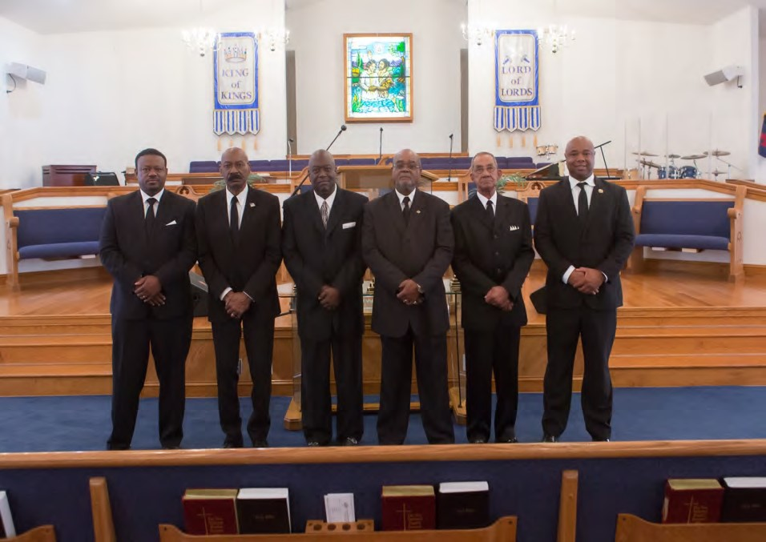

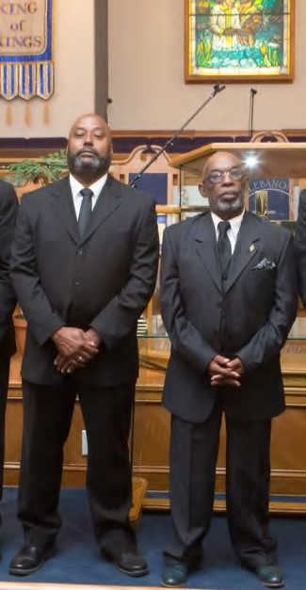
Above, L-R:
Thaddeus C. Lane, Jr.
Carl T. Smith, Sr.
Henry L. Beatty, Jr.
James E. Gary
Charles Brown Carlos Turner

Right, L-R:
Johnnie G. Johns
Ralph E. Doswell

Deaconesses Ministry
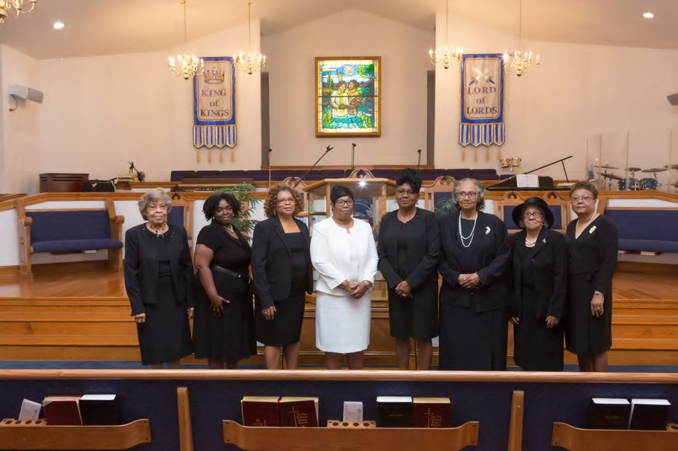
Above, L-R:
Harriett T. Smith, Sonia Beatty, Barbara J. Brown, Janet Johns, Virginia Gary, Doris Waller, Thomas Loraine Hill, Janice Brown
Below, L-R:
Martha Doswell, Ella Ellis, Gladys Harris

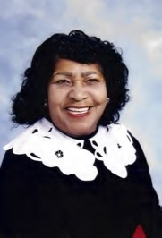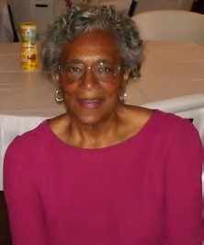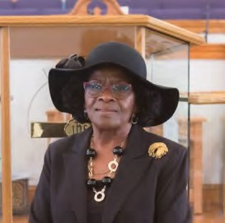

Not Pictured: Theresa Gilchrist, Elnora Davis, Christie Lane

Trustee Ministry
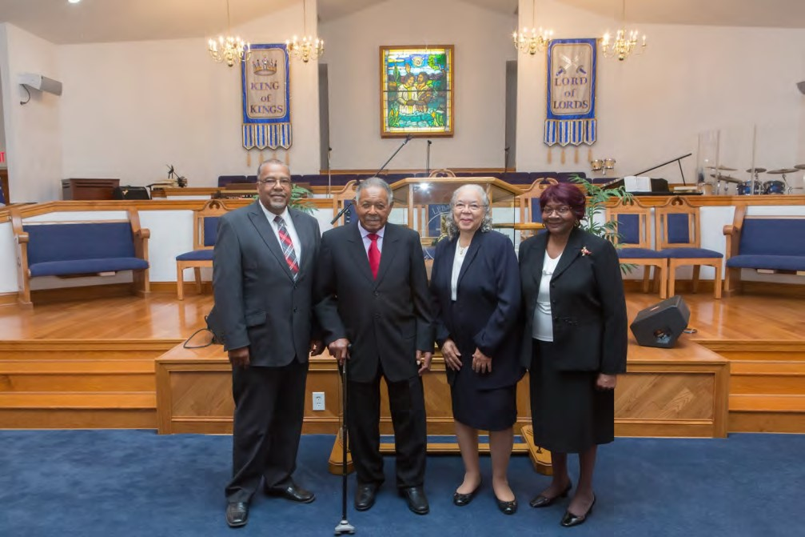
Above, L-R:
Anthony Howell, Purcell G. Bailey, Gladys W. Hardy, Shirley Davis

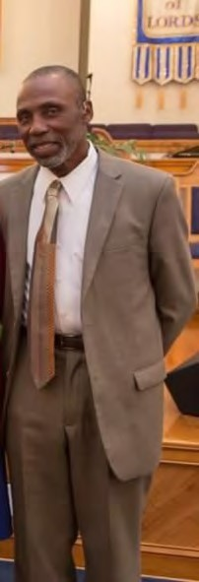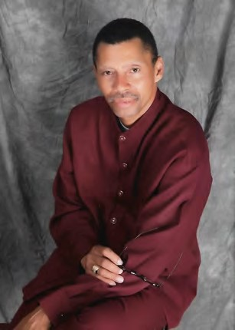
Leonard C. Ruffin Horace L. Thomas, Jr.

Usher Ministry
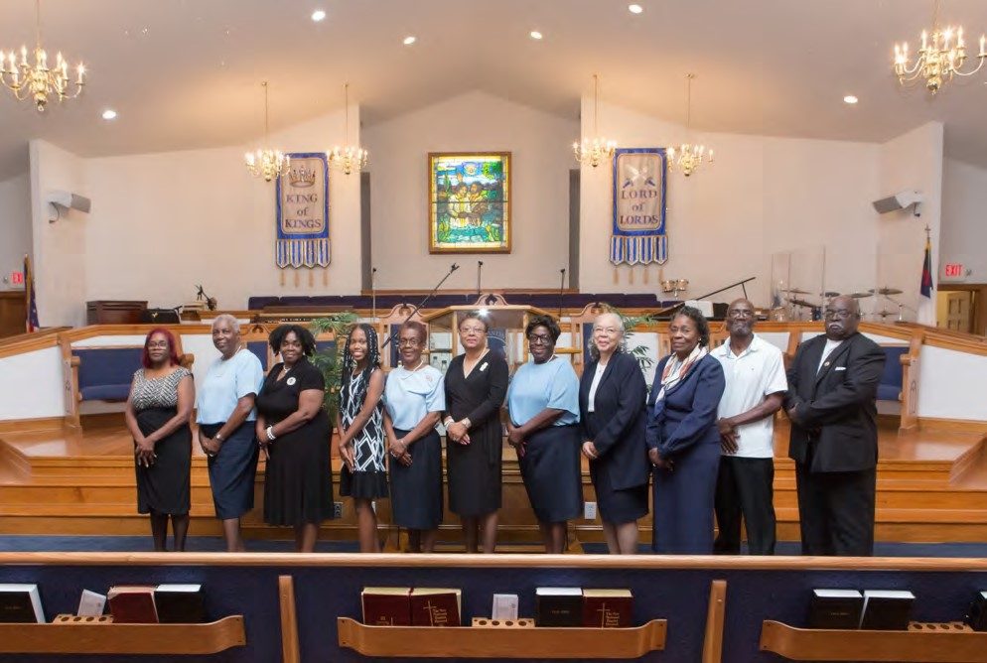

Above, L-R:
Barbara Piker, Harriet Ruffin, Sonia Beatty, Megan Williams,
Phyllis Thomas, Janice Brown, Juanita Parker, Gladys Hardy, Nellie Bailey, Oscar Piker, Larry Doswell

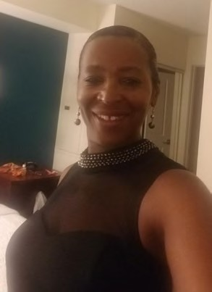

Cleo Harrison Leonard C. Ruffin

Missionary Ministry
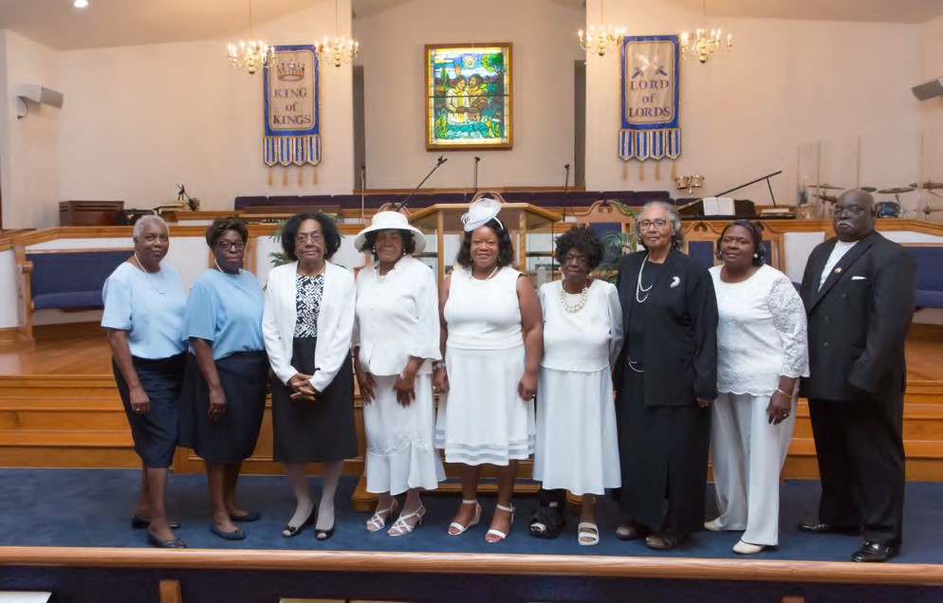
Above, L-R:
Harriet Ruffin, Juanita Parker, Naydean Winfield,
Joyce Pretlow, Sheila Hunt, Clara Bailey, Doris Waller,
Gloria Debrick, Larry Doswell
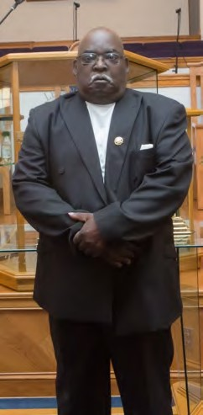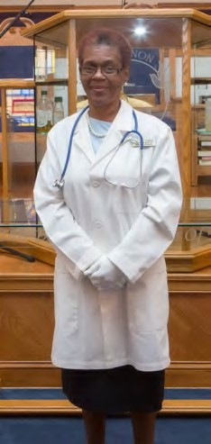

Larry Doswell, Phyllis Thomas, Transportation Ministry Nurse Ministry

Pastor’s Aid Ministry
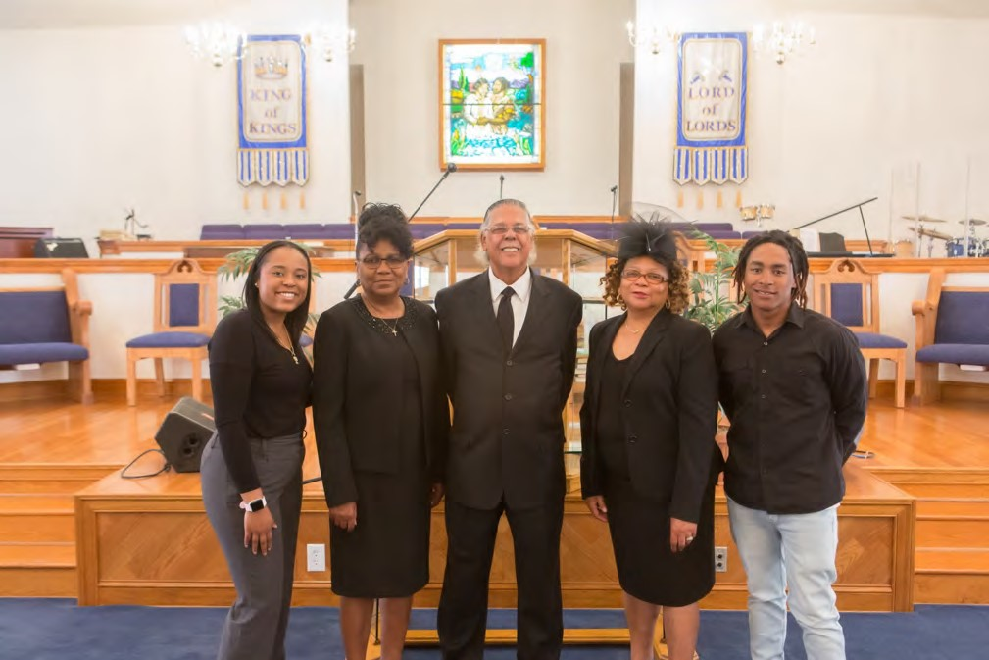

L-R: Tiffany Howell, Virginia Gary, Dennis E. Harrison, Barbara J. Harrison, Antonio Rawlings, Jr.

Cleo Harrison

Hospitality Ministry

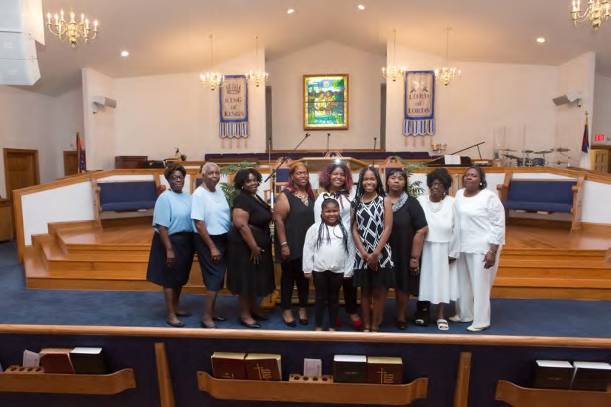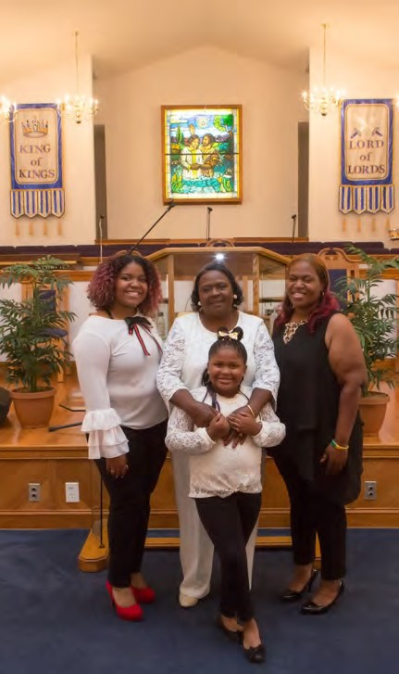

Three Generations, L
-
R:

Ciara Griffin

Gloria J. Debrick

Crystal Debrick
-
Jones

Front: Brickcey Jones

Helping Hands, L-R: Juanita Parker, Harriet Ruffin, Sonia Beatty,
Crystal Jones, Ciara Griffin, Brenda Tynes, Clara Bailey, Gloria J. Debrick Front: Brickcey Jones, Megan Williams

Music Ministry
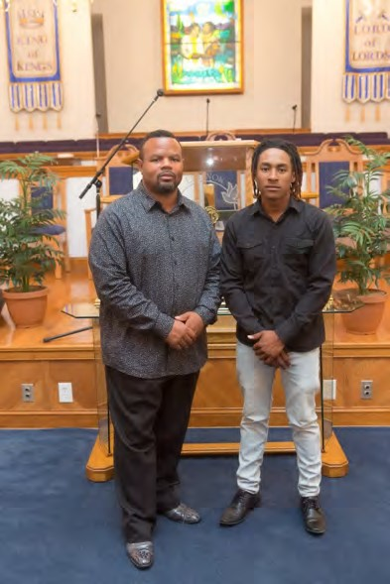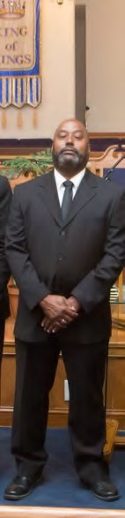

L-R: Rev. Ivan Pretlow, Minister of Music, Antonio Rawlings, Jr.,
Percussionist, Deacon Johnnie Johns, Guitarist
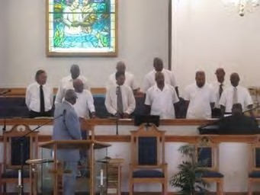

Male Chorus

LBC Sanctuary Choir
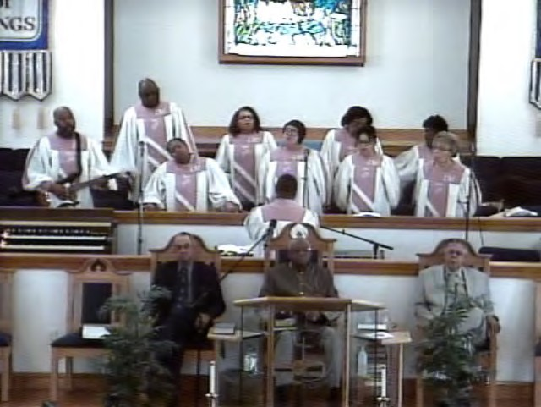

L-R: Front Row: Deacon Johnnie Johns, Guitarist, Brenda Tynes,
LaSonya White, Rene Williams, Harriett Smith
Back Row: Keith Debrick, Barbara Harrison,
Naydean Winfield, Clara Bailey
Rev. Ivan Pretlow, Minister of Music
Not Pictured: Preston Robinson, Virginia Gary

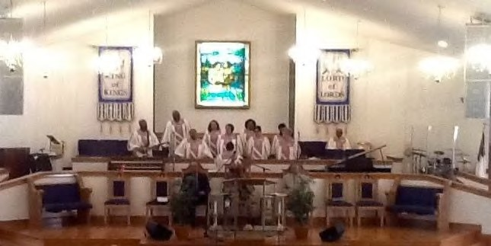

Noon Day Prayer Ministry
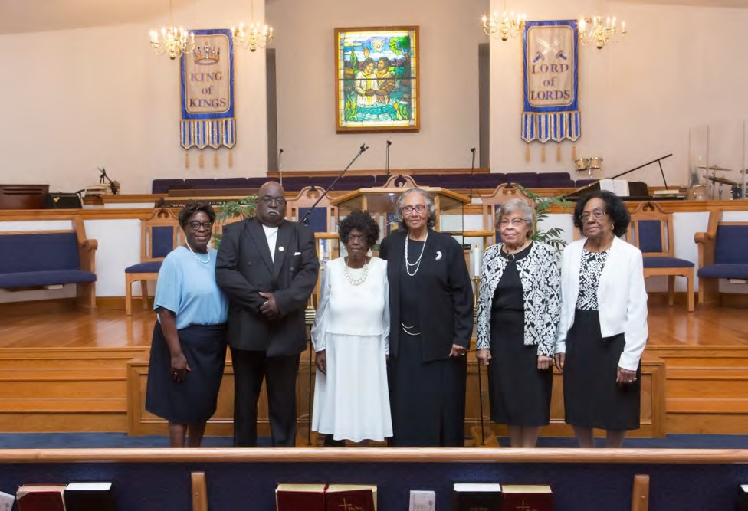
L– R: Juanita Parker, Larry Doswell, Clara Bailey, Doris Waller,
Harriett T. Smith, Naydean Winfield

Media Ministry
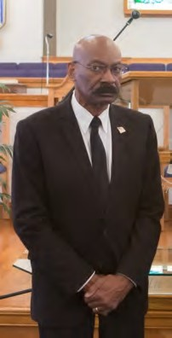

Carl T. Smith, Sr. Horace L. Thomas, Jr..

Sunday School
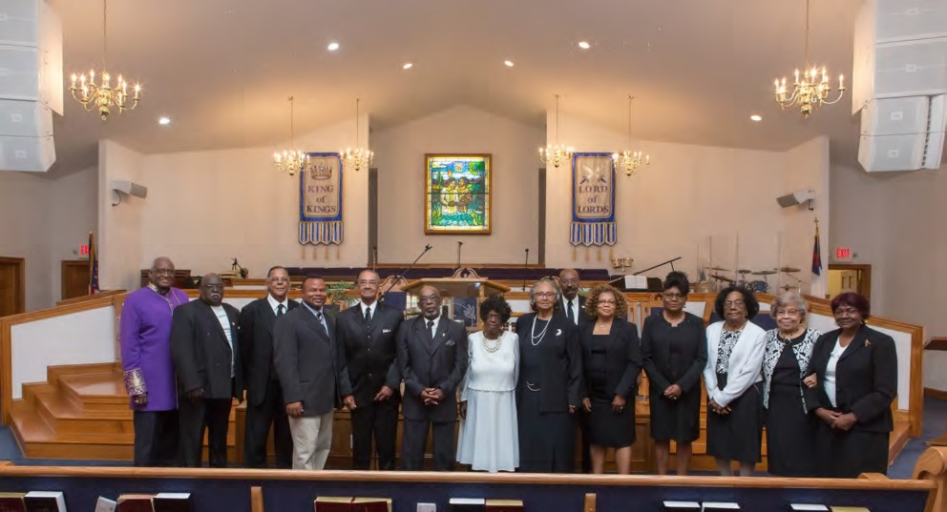

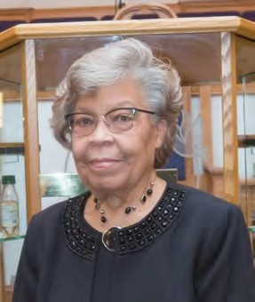
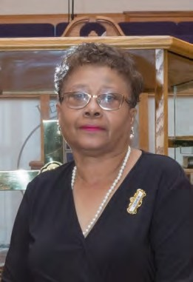
Church Clerk 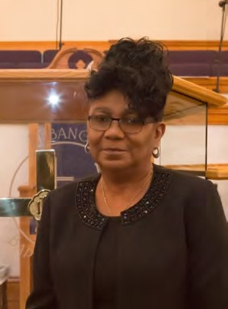

Harriett T. Smith,

Virginia Gary,
Financial Secretary

Janice Brown, Church Treasurer

Youth Ministry
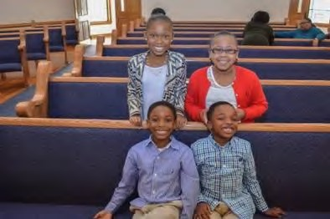
Right, L-R:
“Youth Ushers”
Megan Williams
Kaitlyn Chambers
John Hunt Royal Hunt, Jr.

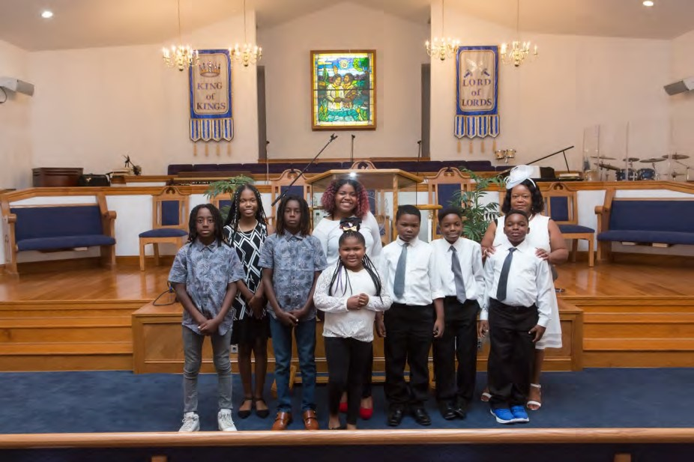
L-R: Allex Rawlings, Megan Williams, Ammon Rawlings, Ciara Griffin, Carl T. Smith III, John Hunt, Royal Hunt, Jr. Front: Brickcey Jones
Youth Coordinator: Sheila L. Hunt

Congregation

“For where two or three are gathered together in my name, there am I in the midst of them.” Matthew 18:20
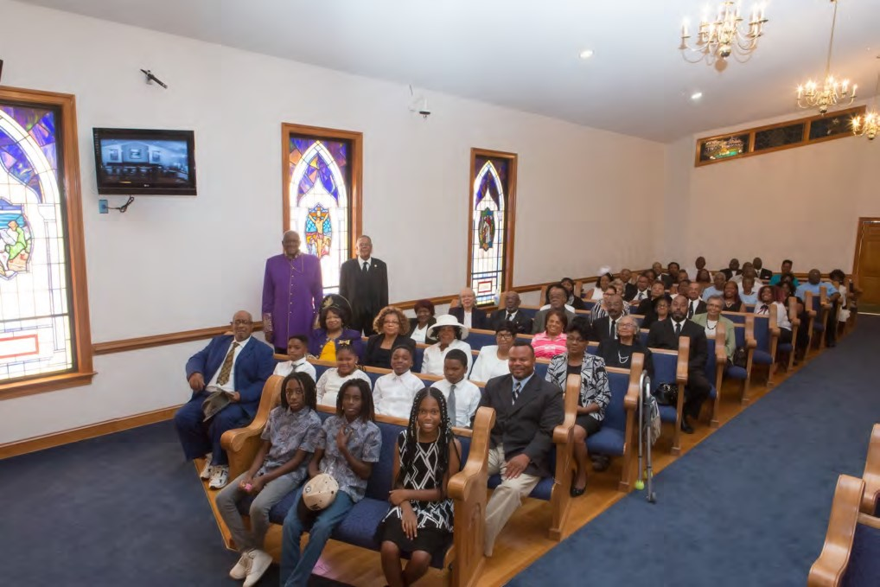
“Take heed therefore unto yourselves, and to all the flock, over the which the Holy Ghost hath made you overseers, to feed the church of God, which he hath purchased with his own blood.” Acts 20:28

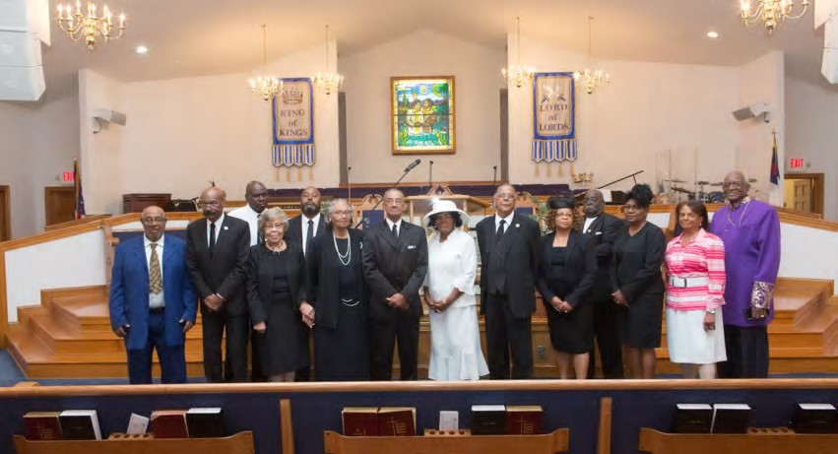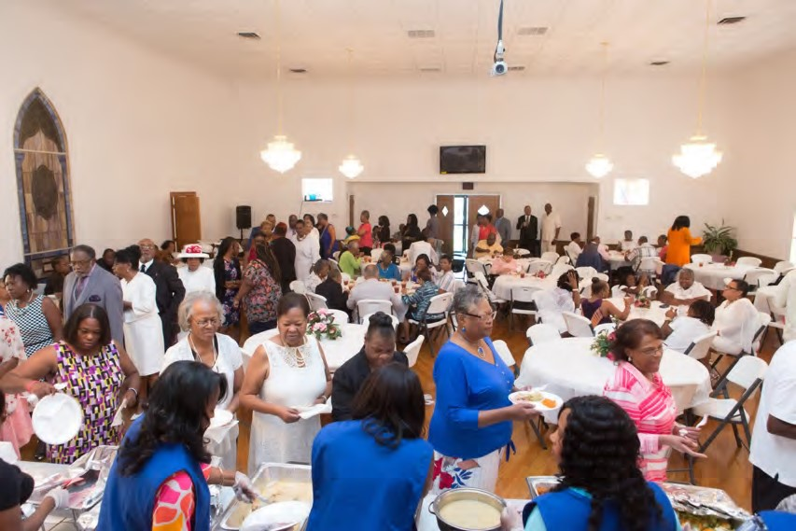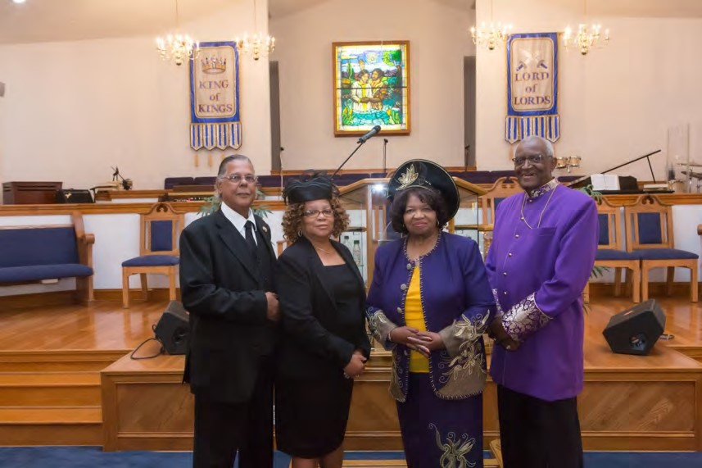

Scenes from the Anniversary Banquet
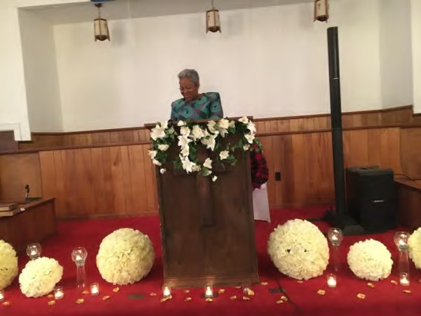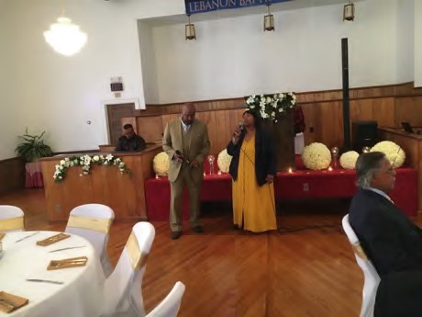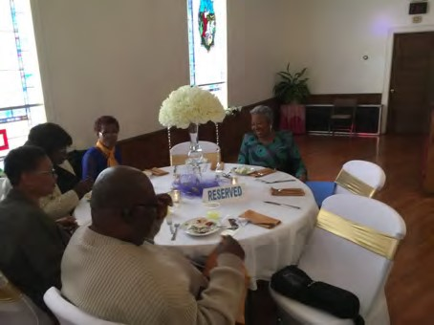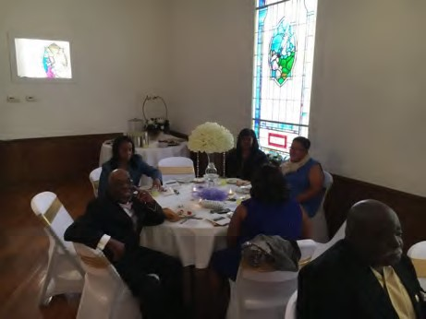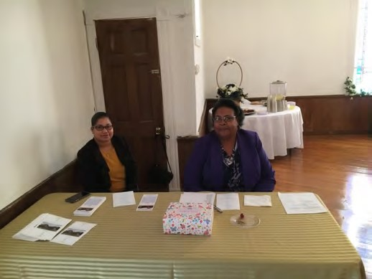

Scenes from 2nd Sunday Homecoming August 2019
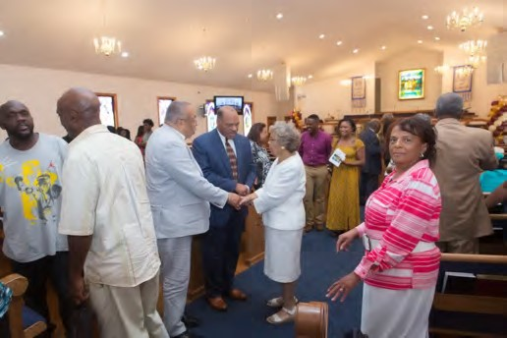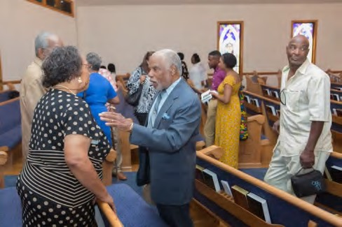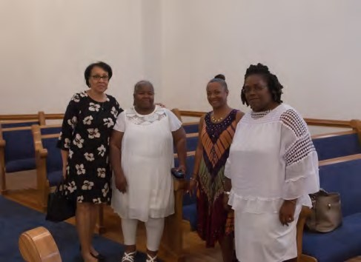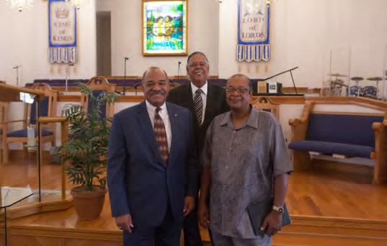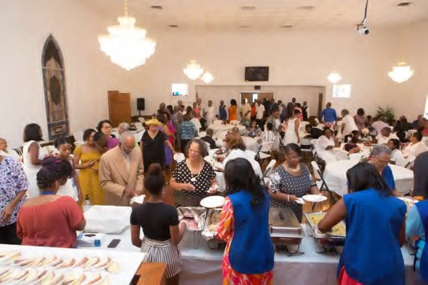

Anniversary Committee
Deaconess Harriett T. Smith, Chair
Sister Barbara Piker
Sister Charetta Howell
Sister Cynthia Howell
Sister Deborah H. Dawson
Sister Juanita Parker
Sister Phyllis Thomas
“Remember the days of old; consider the generations long past. Ask your father and he will tell you, your elders and they will explain to you.”

Deuteronomy 32:7 (NIV)

The Lebanon Baptist Church family wishes to thank all who supported our 150th anniversary week-end of events. We offer special thanks to Deaconess
Elva Whitten, Rev. Dr. Bobby Lee Taylor and Sandy Mount Baptist Church. May God continue to bless you and your families.

____________________________________________________________

Lebanon Baptist Church

Physical Address: 162 Lebanon Road, Spring Grove, VA 23881 Mailing Address: P. O. Box 299, Surry, VA 23883 Phone: 757-294-3551 Website: www.lebanonbaptistsurry.org E-mail: lebanonbaptistsurry@gmail.com

